CERTIFICATE OF CONFORMITY TO OEM REFERENCE

Juratek Product Reference | SAF104
Product Description | Brake Disc
OE Part Number | 4079001000,4079001001,4079001002,4079001003
Application(s): | SAF SK RB 9019
Supplier Quality Approval | BS EN ISO9001: 2008

We certify that the goods detailed above conform to the material & dimensional specifications required by Juratek Ltd and that they are fit for direct OEM replacement.

Print Name: | Andrew Kibler
Signed: | 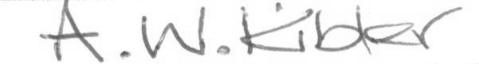
Position: | Quality & Engineering Manager
Date: | 29 July 2026

